Test Cases file: 'tests/government_interest/vafix/parsed_data/TestData/government_interest.csv'
File constructed of user data sent in as example of problematic data set.
Assumes 'tests' directory is in project root.

Test Cases execution instruction:
1. Update [FOLDERS] section of 'config.ini' in project root. Replace instances of <project_root> with the directory the repository is cloned to. Other placeholders do not need to be replaced as this process does not use a database connection to test.
2. Run ‘pytest’ in 'tests/government_interest/vafix/'.
3. Manually inspect 'tests/government_interest/vafix/government_interest/pre_manual/NER_out/edge_cases.csv' to verify favorable changes in solid matches. The 'org' column shows the organization name being matched, the 'with_space' column shows the solid matches for the organization with the new existing lookup logic, and the 'wo_space' column shows the solid matches for the organization with the old existing lookup logic.

Results:
Almost all results are unambiguously favorable, removing incorrectly matches or adding correct matches. There are some instances where an incorrect match is added or a correct match is removed, but these are few and being tagged for further investigation. Some of these are cases where non_government is added in addition to the correct organization, so it will be noted to investigate the non_gov_check function.

Proof of successful execution:
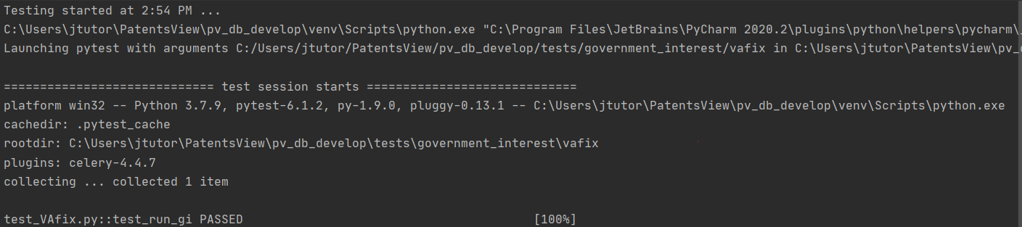

Example output:
